**Enzymes**

* Proteins have many roles in biological organisms. One of the more important are enzymes.
* Enzymes are **proteins** that function as biological catalysts, accelerating the rate of chemical reactions in cells.
* 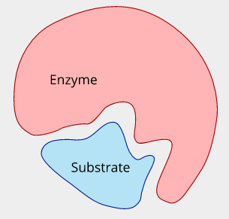Unlike inorganic catalysts, organic catalysts are reaction-specific.
* The model for enzyme function involves a reactant (substrate) interacting with the enzyme's active site. This is often called the “lock and key model”.
* The enzyme's three-dimensional shape (tertiary structure) is critical in this model.

**Enzyme Activity and the Effect of Conditions**

**Temperature:**

* Elevated temperatures easily disrupt the tertiary structure of a protein due to the weak nature of the attractions between polypeptide chains.
* 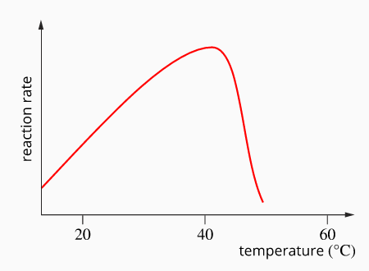When the tertiary structure of an enzyme is disrupted, the enzyme can no longer function properly, and it is referred to as denatured.
* The following graph shows the relationship between temperature and enzyme activity.
* As temperature increases, the enzyme-catalysed reaction rate increases until an optimum temperature is reached. If the temperature exceeds this optimum temperature, the enzyme's structure is disrupted, and the reaction rate decreases rapidly.

**pH:**

* 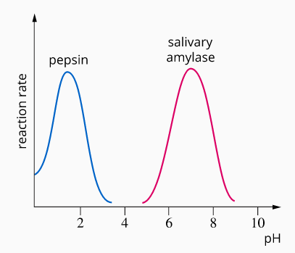Enzymes operate effectively only within a narrow pH range. The effective range is dependent on the type of enzyme. For example, pepsin in the stomach works best in acidic conditions, and salivary amylase in the mouth works best in neutral conditions (see graph).
* If the pH varies too much from the ideal, H+ and OH- ions will disrupt the tertiary structure, causing the protein to denature, preventing it from functioning correctly.
* The pH at which the rate of reaction is fastest is known as the enzyme's optimum pH

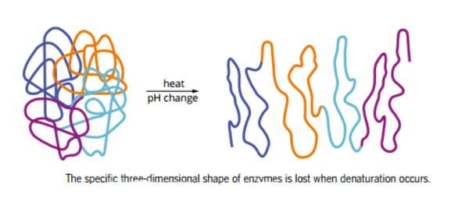

**Enzymes and pH (More Detail)**

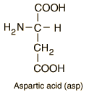The tertiary structure of an enzyme results from the interaction between the charged molecules' side chains (residuals of the amino acids). Charged side chains can repel (same charge) or attract (opposite charge) each other. The charge of the side chains can be affected by pH.

**Acidic Side Chains**

A higher proportion of the carboxyl group disassociates at a high pH (low concentration of H+).

**COOH(aq) + H2O(l) ⇋ COO- (aq) + H3O+**(aq)

This leaves a negative charge at the site of the carboxyl group. This reaction is reversed at low pH.

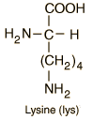**Basic Side Chains**

At low pH (high concentration of H+), more amino functional groups bind to protons.

**NH2(aq) + H3O+(aq) ⇋ NH3+(aq) + OH-(aq)**

This results in a positive charge on the site of the amino group. This reaction is reversed at high pH.

**Therefore**

* pH-dependent reactions can change the side chains' electric charges and the enzyme's shape. A pH range exists at which the enzyme will be most efficient in performing the reaction it was designed. On either side of that optimum, the effectiveness of the enzyme will decline until it cannot function anymore.
* The change in enzyme activity within 2-3 pH units to either side of the optimum is generally reversible. This means that no permanent damage is done to the enzyme. Adjusting the pH to the optimal range can restore total enzymatic activity.
* A more severe pH change of 3+ units is likely to denature (destroy) the enzyme due to the significant irreversible changes in the enzyme's structure.

**Enzymes and Temperature (More Detail)**

Increasing the Temperature

* Increased kinetic energy of the enzyme particles can break some existing intermolecular attractions, changing enzyme shape.
* As with pH, small temperature increases are reversible, but significant temperature increases are irreversible due to the total breaking of some intermolecular bonds and new different bonds forming. The enzyme is denatured.

Decreasing the Temperature

* Lower temperatures will lower reaction rates due to decreasing particle energy.
* However, the enzyme is less likely to be permanently damaged, as with extreme temperatures.